Customer Notice –
Harvest Fest Re-Route

October 18th, 2024

To accommodate the annual Harvest Festival in Saco on Saturday, 10/18/24, BSOOB Transit Services will be re-routed between 9:00am and 5:00pm

#52 -White will not operate on Main Street Saco between the Saco Transportation Center and Beach Street. Connections can be made in Saco at Shaw’s, Scammon Street, and North Street.
#53 – Blue will not operate on Main Street Saco between the Saco Transportation Center and Beach Street. Connections can be made in Saco at Shaw’s, Scammon Street, and North Street.
#54 – Silver will not operate on Main Street Saco and Cutts Avenue. All other stops served as normal.
#60 – Green will not operate along Main Street Saco. Connections will remain along Route 1 north of Beach Street.
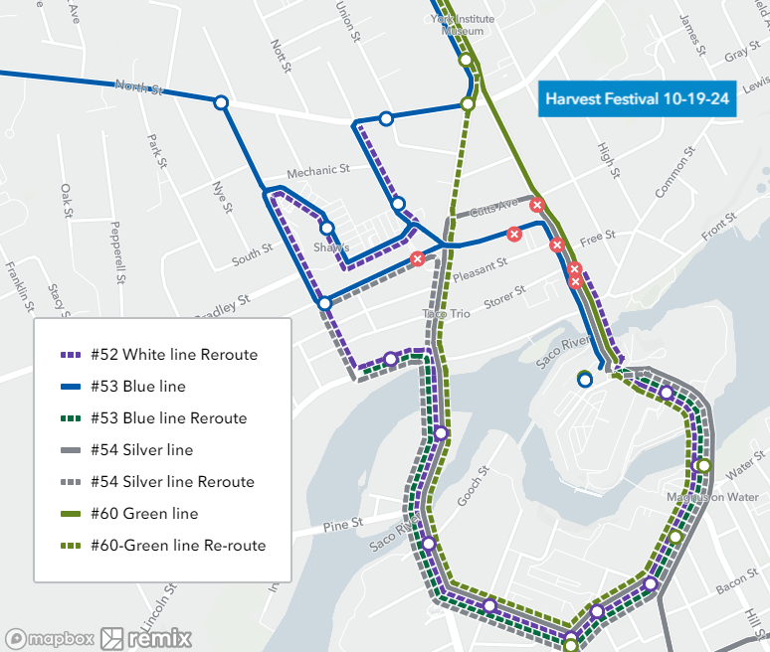

Should you have any questions, please call us at 207-282-5408. Real time route information is available at www.bsoobtransit.org

