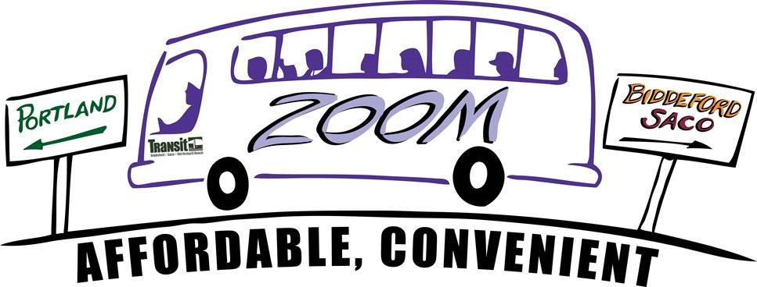

In observance of the July 4th holiday, the ZOOM Express service will not be running on Friday, July 3rd.

ZOOM Express will run again on Monday, July 6th.

Thank you for riding with BSOOB Transit.